Software Requirements Specification
for
COVID-19 data visualization tool
Version 1.0

25.11.2020
Table of Contents
1. Introduction 1
1.1 Purpose 1
2. Overall Description 1
2.1 Product Perspective 1
2.2 Product Functions 1
2.3 User Classes and Characteristics 1
2.4 Operating Environment 1
2.5 Design and Implementation Constraints 2
2.6 Assumptions and Dependencies 2
3. External Interface Requirements 2
3.1 User Interfaces 2
3.2 Hardware Interfaces 2
3.3 Software Interfaces 3
3.4 Communications Interfaces 3
4. System Features 4
4.1 Visualize latest detailed stats 4
4.2 Visualize historical detailed stats 5
4.3 Visualize regional stats by country 5
4.4 Interacting with the choropleth map 6
5. Other Nonfunctional Requirements 6
5.1 Performance Requirements 6
5.2 Safety Requirements 6
5.3 Security Requirements 6
5.4 Software Quality Attributes 7

Revision History
Name | Date | Reason For Changes | Version

Introduction

Purpose
The goal of this project is to raise awareness on the evolution of COVID. The idea is to associate data and visualization tools such as graphs and tables, which will provide relevant information to the public regarding the present situation of COVID.

Overall Description

Product Perspective
The goal of this product is to reach the general public, not experts familiar with graphs and numbers. For this reason, we will put a lot of effort on simplifying the visualization methods and representing it in such a manner that is accessible to everyone.

Product Functions
The major functions of the application are the following:
- Showing historical data regarding the daily confirmed cases, tested cases, recoveries, deceased;
- Displaying regional data regarding the after mentioned data groups;
- Displaying the evolution of cases through the use of graphics;
- Showing a choropleth map with the data (where each state is shaded in proportion to a statistical variable).

User Classes and Characteristics
Given the fact that the application is conceptualized as one for general use and the subject is one of wide interest, we have only one class of users, general users. All the users will have the same overview of the data, and the same accesses to filter and navigate through the displayed data.

Operating Environment
The application will run in a browser and use a public API which is being updated daily with new data regarding the daily confirmed cases, the number of tests which were done in the previous day, the number of people recovered and those who died.

Design and Implementation Constraints
Because of the social implications of the analyzed phenomenon, we have to keep in mind a few constraints in the way in which we display the data.
Because COVID-19 testing and reporting are inconsistent among countries, it’s easy to misinterpret the data. That makes it especially important to create clear and accurate visualizations. Otherwise even simple and minimalistic graphics can be misleading.

Though this is a world-wide crisis, each state or territory reports its data differently. We track numbers provided by each state, but the quality and frequency of reports vary widely. Transparency is crucial. There is a need to publish details about inconsistencies in data reporting for every state and territory.

Charting the number of positive tests alone is often problematic. Simple case counts show where people are being tested, not necessarily where people are sick.
For example, a country that reports three cases of COVID-19 after testing 2,000 people is probably in a different stage of its outbreak than a state that reports three cases but has only tested 20 people. But if all you have is a case count, those states look exactly the same. That is why it’s necessary to include the total number of tests as a denominator.

Assumptions and Dependencies
The main dependency of the application is the public API from which we will retrieve the data. The problem which arises from this is the fact that we do not have the certainty that the retrieved data is correct. In these conditions we must assume that the received data is correct, but as well we have to inform the users about the uncertainty of it.

External Interface Requirements

User Interfaces
Logical Characteristics: The GUI of the product shall be designed in HTML using ASP .NET Core RazorPages, Bootstrap and JavaScript allowing a multitude for a graphical interaction between the data, the graphics which represent the data and the user.

Aspects: Inputs will be entered via standard web controls such as combo box, check box, text box and calendar.
Navigation and acceptance will be handled with buttons. Interface designs can be found in the wireframes document.

Hardware Interfaces
Web or mobile browsers will be used to access the platform.

Software Interfaces
The platform communicates with the API in order gather the required data from the server, though we are not aware of the infrastructure behind the API. We’ll use a number of HttpGet methods in order to retrieve the data and filter it.
C# and .Net Core will be used to validate the input, and to retrieve/display the results.

Communications Interfaces
The website will use TCP/IP protocol for communication with the server, and HTTP protocol for website, as data will be retrieved using a number of HTTP-GET methods.

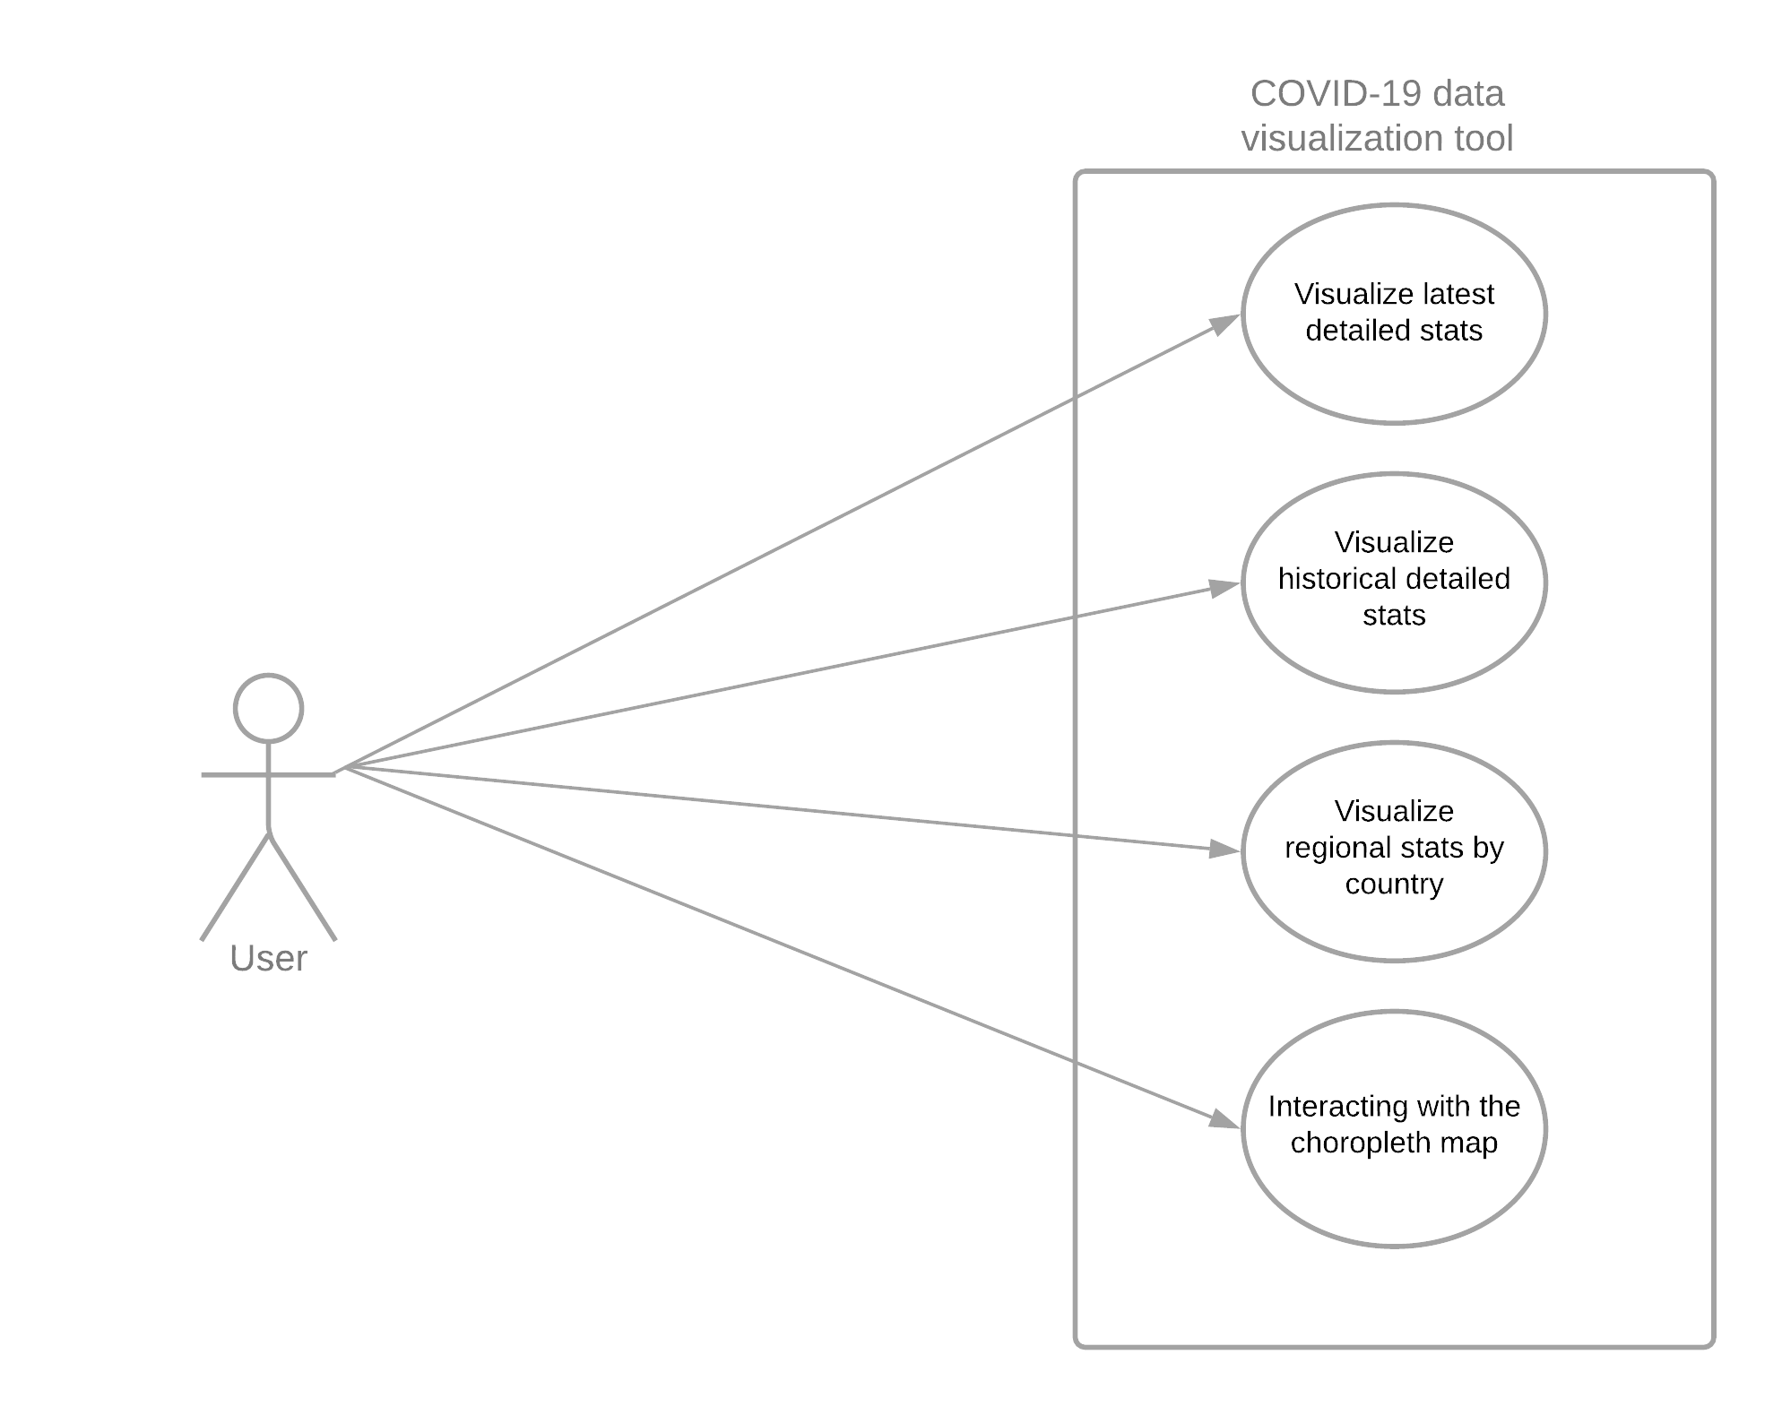
System Features

Figure 1. COVID-19 Data Visualization Tool Use Cases

Visualize latest detailed stats
4.1.1 Description and Priority
The users will load the webpage and be prompted with the latest information regarding the global situation of the COVID-19 pandemic. This feature is high priority.
4.1.2 Stimulus/Response Sequences
There is a no stimulus/response sequence in this case as this is the default state of the webpage.

4.1.3 Functional Requirements
REQ-1: The user will navigate to the webpage. At this moment, the site will call a HttpGet method to retrieve the latest data from the COVID-19 API. The data will be displayed in a table which will be linked with a dynamic graphic.

Visualize historical detailed stats
4.2.1 Description and Priority
The users may navigate through historical data by selecting a specific passed date, which will modify the data shown in the table and the form of the dynamic graphic. This feature is high priority.
4.2.2 Stimulus/Response Sequences
“Calendar” button/widget: A calendar widget will be displayed, from which the user can select only passed dates. The future ones will be crossed out. After selecting the date the table and graphic on the page will be modified.
4.2.3 Functional Requirements
REQ-2: User will select the date, the system will pass the selected date as a parameter to the API and retrieve only the relevant data for that date.

Visualize regional stats by country
4.3.1 Description and Priority
The user can use the Search functionality in order to return data from a specific country. This feature is a high priority.
4.3.2 Stimulus/Response Sequences
“Search” bar: Suggestions for the search will be shown dynamically as the user inserts the name of the country of interest. An error message will be displayed in the case of an invalid search. The entered country name will be used as a filtering criteria, and the results will be shown in the table and graphic respectively.
4.3.3 Functional Requirements
REQ-3: User will enter search text into the search textbox and click the search button. The system will pass the country name as a parameter to the HttpGet method and retrieve the relevant data for that respective country.

Interacting with the choropleth map
4.3.1 Description and Priority
The user can hover over the choropleth map from the home page and receive quick data about the COVID situation in each country. This a medium priority feature.
4.3.2 Stimulus/Response Sequences
Hovering over the Map: Quick data will be displayed in an widget regarding the COVID stats of the selected country when the user hovers the mouse over that respective country. The hovered country name will be used as a filtering criteria.
Clicking on a certain country: The click will redirect the user to the page dedicated for the stats of that specific country.
4.3.3 Functional Requirements
REQ-3: User will hover over the map and the system will show the widget . At an onclick() action the system will redirect the user to a page with the country’s COVID pandemic stats. It will name as a parameter to the HttpGet method and retrieve the relevant data for that respective country.

Other Nonfunctional Requirements

Performance Requirements
The system will be available for 7/24 hours.
The response time of the application should be less than 2, as the user has to remember information throughout several tables and graphics, the response time must be short.

Safety Requirements
The website must specify that the data is not entirely accurate and provide the name of the provider of that data.

Security Requirements
There are no security requirements to be fulfilled because, as specified earlier the website is meant for general use.

Software Quality Attributes
Software quality requirements for this platform are:
- Availability: The system will be 7/24 available. Availability will be reported by the web hosting company.
- Usability: System usability will be measured via user surveys.
- Performance: Performance of functions will be tested for timing adequately.
- Functionality: Functionality will be evaluated via user feedbacks from the system.

